Name: | Index No.: | CT Group: 09

PIONEER JUNIOR COLLEGE, SINGAPORE

JC 2 PRELIMINARY EXAMINATION 2010
HIGHER 1

CHEMISTRY 8872/02

Paper 2 21 SEPTEMBER 2010

2 hours
Candidates answer Section A on the Question Paper

Additional Materials: Answer Paper
Data Booklet

READ THESE INSTRUCTONS FIRST

Write your Centre number, index number and name on all work you hand in.
Write in dark blue or black pen on both sides of the paper.
You may use a soft pencil for any diagrams, graphs or rough workings.
Do not use staples, paper clips, highlighters, glue or correction fluid.

Section A
Answer all the questions

Section B
Answer two questions on separate answer paper

You are reminded of the need for good English and clear presentation in your answers.

At then end of the examination, fasten all your work securely together.
The number of marks is given in brackets [ ] at the end of each question or part question.

FOR EXAMINER’S USE
PAPER 1 | SECTION A |  | SECTION B
/ 30 | 1 | / 16 | 4 | / 20
/ 30 | 2 | / 14 | 5 | / 20
/ 30 | 3 | / 10 | 6 | / 20
/ 30 | TOTAL | / 40 | TOTAL | / 40
PERCENTAGE |  | / 100 | GRADE

This document consists of 14 printed pages.

Pioneer Junior College

Section A

Answer all questions in this section
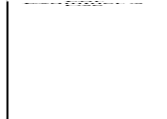
1 | This question is about elements and their compounds in period 3.
 | (a) | Both magnesium and phosphorus can form chlorides. Magnesium chloride, MgCl₂, has a melting point of 714 ºC. Phosphorus (III) chloride, PCl₃, a trigonal pyramidal molecule, can react further with chlorine to form phosphorus (V) chloride, PCl₅, a trigonal bipyramidal molecule.
 |  | (i) | Construct a dot-and-cross diagram for magnesium chloride:
 |  | (ii) | Magnesium oxide has a melting point of 2852 °C. Explain why magnesium oxide has a higher melting point than magnesium chloride.  [1]  [3]
 | (b) | (i) | Explain why PCl₃ is not a trigonar planar molecule using the valence shell electron pair repulsion theory.
 |  | (ii) | Explain why PCl₅ can exist but not MgCl₅ ?  [4]
When PCl₅ dissolves in water, it hydrolyses in water to produce hydrochloric acid, HCl(aq) and phosphoric acid, H₃PO₄(aq) with pH = 1

When aluminum chloride is dissolved in water, it also hydrolyses in water to produce an acidic solution.

Both acidic solutions produced from the reaction of PCl₅ and AlCl₃ with water can react with sodium carbonate to give carbon dioxide gas.

 | (c) | (i) | Write a balanced equation to show the reaction between PCl₅ and water.
 |  | (ii) | Explain using equation(s) why aluminium chloride reacts with water to produce an acidic solution ?
 |  | (iii) | The aqueous chlorides of the period 3 element give different pH.  Write down the pH of the aqueous chlorides in the table provided.
   | aqueous NaCl | aqueous MgCl₂ | aqueous AlCl₃ | aqueous SiCl₄ | aqueous PCl₃
  pH
 |  | (iv) | Construct a dot-and-cross diagram of the carbonate anion in sodium carbonate.  [7]
 | (d) | The electrical conductivity of some Period 3 elements is shown below.  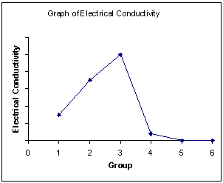  Na Mg Al Si P S
 |  | (ii) | Explain why there is an increasing electrical conductivity from sodium to aluminium?
 |  | (iii) | Explain why there is no electrical conductivity for phosphorus and sulfur?  [2]  [Total 16]
For Examiner’s Use
2 | For each of the following organic compounds, determine the type of isomerism they exhibit and suggest a simple chemical test to distinguish them, indicating the observations you would see.  For Examiner’s Use
 | (a) | 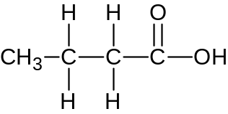  and  butanoic acid  ethyl ethanoate  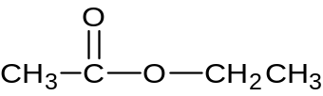
 |  | (i) | Type of isomerism: ________________________________
 |  | (ii) | Reagents and conditions: ________________________________  ________________________________  Observations for butanoic acid:  _____________________________________________________  _____________________________________________________  Observations for ethyl ethanoate:  _____________________________________________________  _____________________________________________________  [3]
 | (b) | 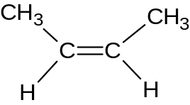  but-2-ene but-1-ene  For Examiner’s Use  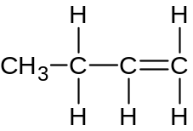
 |  | (i) | Type of isomerism: _____________________________________
 |  | (ii) | Reagents and conditions: ________________________________  ________________________________  Observations for but-2-ene:  _____________________________________________________  _____________________________________________________  Observations for but-1-ene:  _____________________________________________________  _____________________________________________________  [4]
 | (c) | But-2-ene can exhibit other types of isomerism besides the one mentioned in (b)(i)  Draw each isomer belonging to the two other types of isomerism in each of the two boxes shown below.  (i)  (ii)
 | [2]
 | (d) | The diagram shown below is an energy cycle involving but-1-ene at 25ºC and 1 atmospheric pressure.  For Examiner’s Use  ΔH^{θ}₁  4C(g) + 4H₂(g) CH₃CH₂CH=CH₂ (g)  + 6O₂(g) + 6O₂(g)  ΔH^{θ}₂ ΔH^{θ}₃  4CO₂(g) + 4H₂O(l)
 |  | (i) | Calculate the standard enthalpy change, ΔH^{θ}₁ above using the following bond enthalpies.
  Bond | Bond enthalpy / kJ mol⁻¹
  H-H | 436
  C-H | 410
  C-C | 350
  C=C | 610
 |  | (ii) | The standard enthalpy change, ΔH^{θ} ₁ does not represent the standard enthalpy change of formation of but-1-ene. Explain why.
 |  | (iii) | Use the following data below as well as your answer in (d)(i) to calculate the standard enthalpy change of combustion of but-1-ene  For Examiner’s Use  ΔH ^{θ} _{c}( C(g) ) = - 1110 kJ mol⁻¹  ΔH ^{θ} _{c}(H₂) = - 286 kJ mol⁻¹  [5]  [Total: 14]

3 | Apricot kernels contain glycoside amygdalin, an organic compound which turns into deadly hydrogen cyanide acid, HCN, when the kernel is crushed or injured. High doses of hydrogen cyanide can cause coma with seizures and cardiac arrest, leading to death in a matter of minutes. A fatal dose for a human can be as low as 1.50 mg kg⁻¹ of body weight. (1 mg = 1.00 x 10⁻³ g)  For Examiner’s Use  The forensics department of the local law enforcement agency was trying to determine the cause of death of a 75 kg deceased man who was found at home on the couch with a few empty packets of apricot kernels lying on the ground.  A 10 cm³ sample of blood (a typical human has 71 cm³ of blood per kg body mass) obtained from the body and hydrogen cyanide containing haemoglobin was isolated and dissolved to form 25 cm³ of solution. This sample of the haemoglobin was oxidised by potassium dichromate, K₂Cr₂O₇, to determine the amount of Fe²⁺ which is also equal to the amount of hydrogen cyanide present. 1.70 cm³ of 0.00100 mol dm⁻³ acidified K₂Cr₂O₇ solution was required for complete reaction.
 | (a) | Write a redox equation between Fe²⁺ and Cr₂O₇²⁻.  [1]
 | (b) | Show by oxidation number that the reaction in (a) is a redox reaction.  [1]
 | (c) | Calculate the total amount of hydrogen cyanide, HCN in the 25 cm³ of solution.  [2]
 | (d) | Calculate the amount of hydrogen cyanide, HCN, in the body of the deceased man.  [1]
 | (e) | Calculate the concentration of HCN in mg kg⁻¹ and hence determine if the cause of death was due to hydrogen cyanide poisoning.  For Examiner’s Use  [2]
 | (f) | (i) | Given that the 25 cm³ sample of hydrogen cyanide solution in (c) has a pH of 6.30, show quantitatively that HCN is a weak acid.
 |  | (ii) | What is the effect of adding universal indicator to this 25 cm³ sample of hydrogen cyanide solution mentioned in (f)(i)?  [2]  [2]
 | (g) | Explain why potassium chloride, KCl , cannot be used to oxidise Fe²⁺?  [1]  [Total: 10]

Section B

Answer two of the three questions in this section on separate answer paper

4 | An organic compound, E, has the molecular formula C₁₁H₁₄O₂. When E is heated with aqueous HCl, benzoic acid and F with formula C₄H₉OH, is formed. When F is heated with hot Al₂O₃, G, C₄H₈ is produced. Heating G with acidified potassium manganate(VII) produces H, C₃H₆O. H produced an orange precipitate with 2,4-dinitrophenylhydrazine but does not react with Tollens’ reagent.
 | (a) | Draw the structures of compounds E to H and explain the above reactions. Write chemical equations to support your answer. [10]
1-aminopropan-2-ol is produced from ethanol by the following synthesis pathway.
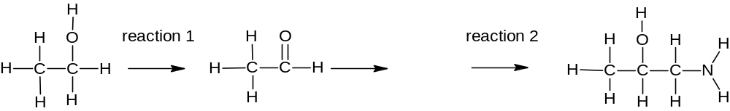

J

1-aminopropan-2-ol
 | (b) | (i) | Draw the displayed formula of compound J.
 |  | (ii) | Write the reagents and conditions for reactions 1 and 2. [3]
 | Alkene is an unsaturated organic compound and undergoes addition. Benzene which is also an unsaturated organic compound undergoes substitution.
 | (c) | Explain why benzene undergoes substitution instead of addition? [2]
 | Chlorofluorocarbons, CFCs, are small alkane molecules where some hydrogen atoms have been substituted by chlorine and fluorine atoms. CFCs are used as aerosol propellant in spray can and as refrigerant. A typical CFC is CH₃CHClF.
 | (d) | (i) | (i) Explain why the synthesis of CH₃CHClF from fluoroethane, CH₃CH₂F and chlorine produces a mixture of products?
 |  | (ii) | (i) CH₃CHClF can be converted to CH₃CH(OH)F. Give the reagents and conditions for this reaction.
 |  | (iii) | (i) Explain why C-F bond in CFC does not undergo the reaction in (d)(ii)?
 |  | (iv) | Why does this CFC present an environmental concern?
 |  | (v) | Suggest one way to reduce the use of CFCs. [5]  [Total: 20]
5 | Sulfuric acid, H₂SO₄, is a strong mineral acid which is an important chemical used in industry and in the school laboratory.  One step in the manufacture of sulfuric acid by the contact process involves the reaction between sulfur dioxide and oxygen.  2 SO₂ (g) + O₂ (g) 2 SO₃ (g)  When 72 dm³ of sulfur dioxide gas and 32.0 g of oxygen gas are reacted in a 200 dm³ reaction vessel at a constant temperature of 25ºC and 1 atmospheric pressure, the percentage conversion of sulfur trioxide was 80% at equilibrium.
 | (a) | (i) | (i) Calculate the initial amount of sulfur dioxide gas and initial amount of oxygen gas at 25ºC and 1 atmospheric pressure.
 |  | (ii) | Explain which reagent is the limiting reagent.
 |  | (iii) | Calculate the equilibrium constant with its units.
 |  | (iv) | What will happen to the yield of SO₃(g) when the reversible reaction at equilibrium is conducted at 2 atmospheric pressure? [6]
 | (b) | (i) | Sulfuric acid is a dibasic strong acid. Explain the underlined term.
 |  | (ii) | A 100 cm³ of solution contains 0.980 g of sulfuric acid. Calculate the pH of the sulfuric acid solution. [4]
The titration curve is obtained when sodium hydroxide is added to sulfuric acid. The equivalence point is reached when 25.0 cm³ of sodium hydroxide is added.
pH
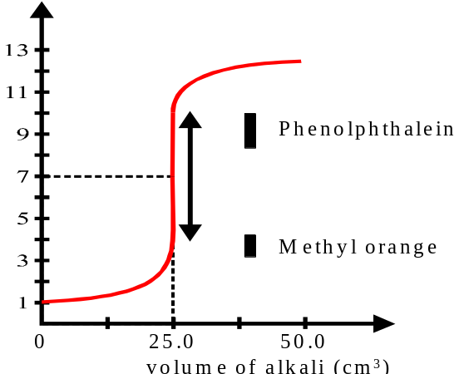

Equivalence pH = 7

Volume of NaOH / cm³

Methyl orange and litmus are suitable indicators to determine the equivalence point of the titration between sulfuric acid and sodium hydroxide solution.
Indicator | Working pH range
Methyl Orange | 3.2 – 4.4 | Colour of methyl orange < pH 3.2 (red) | Colour of methyl orange > pH 4.4 (yellow)
litmus | 6.0 – 8.0 | Colour of litmus  < pH 6.0 (red) | Colour of litmus  > pH 8.0 (blue)

 | (c) | (i) | Explain why methyl orange is a suitable indicator?
 |  | (ii) | Explain why litmus is a suitable indicator? [3]
Sulfuric acid is needed in many organic reactions. The reaction scheme below shows the reaction involving sulfuric acid.

M
Concentrated H₂SO₄, CH₃COOH, heat

Excess concentrated H₂SO_{4,}
170ºC

L
H₂SO₄(aq), heat
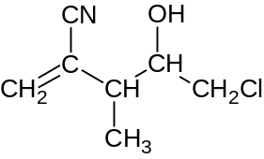

P + Q

+ other minor product(s)
K
Concentrated H₂SO₄, followed by H₂O, warm

N

 | (d) | (i) | Draw the structures of L, M, N. If other products are also produced, draw the major product only.
 |  | (ii) | Draw the structures of P and Q given that P has a higher net dipole moment.
 |  | (iii) | Explain why P has a higher net dipole moment than Q? [7]  [Total: 20]

6 | The standard enthalpy change of formation of boron trifluoride between boron solid and fluorine gas to produce gaseous boron trifluoride in a reaction vessel is shown below:  B (s) + 3/2 F₂ (g) BF₃ (g)
 | (a) | With reference to boron trifluoride, define the standard enthalpy change of formation of boron trifluoride, ∆H^{θ}_{f}(BF₃). [1]
 | The order of reaction with respect to fluorine is one. The half-life of the reaction is 10 days. Given that the initial concentration of fluorine is 0.600 mol dm⁻³.
 | (b) | Sketch a graph of [F₂] against time showing two half-lives in your graph. [2]
 | (c) | Explain what will happen to the rate of formation of gaseous boron trifluoride
 |  | (i) | when the volume of the reaction vessel is increased ?
 |  | (ii) | when a bigger piece of solid Boron is used ? [4]
 | A copper catalyst can increase the rate of formation of gaseous boron trifluoride.
 | (d) | (i) | Write the electronic configuration of Copper atom.
 |  | (ii) | Using relevant diagram, explain how the copper catalyst can increase the rate of formation of gaseous boron trifluoride [4]
 | (e) | (i) | Write an equation to represent the first ionisation energy of Boron.
 |  | (ii) | Boron has a lower first ionisation energy than Beryllium. Explain why.  [3]
 | (f) | (i) | BF₃ reacts with NH₃ to form molecule S. Draw a structure to represent the molecule S.
 |  | (ii) | Explain the criteria for forming the structure you have proposed in (f)(i)
 |  | (iii) | Show the hydrogen bonding between two molecules of S, showing dipoles and other relevant information. [5]
 | BF₃ reacts with water to form a weak acid, boric acid, H₃BO₃ as one of its products. Excess H₃BO₃ reacts with aqueous NaOH to form buffer solution consisting of aqueous H₃BO₃ and aqueous NaH₂BO₃.
 | (g) | Write an ionic equation to show how this buffer solution decreases the acidity when a small amount of acid is added. [1]

END OF PAPER [Total: 20]

